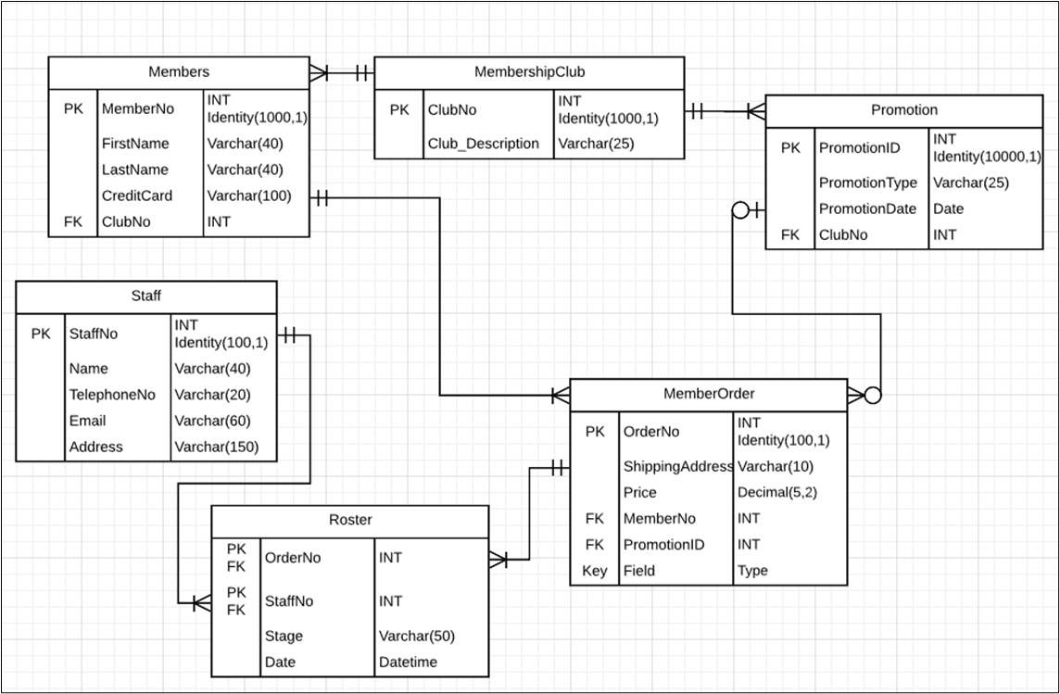
General SQL Answer

Query 1: staff details for 105, 108, 110 and 113
SELECT s.StaffNo, s.Name, s.TelephoneNo, s.Email, s. Address
FROM Staff AS s
WHERE s. StaffNo IN (105, 108, 110, 113);

Query 2: member full name, order count and total price
SELECT m.MemberNo, m.FirstName + ' ' + m.LastName AS FullName, o.OrderCount, o.TotalPrice
FROM Members AS m
INNER JOIN (
SELECT MemberNo, COUNT_BIG(*) AS OrderCount, SUM(Price) AS TotalPrice
FROM MemberOrder
GROUP BY MemberNo)
AS o
ON o.MemberNo = m.MemberNo;

Query 3: order details with member name and promotion if it exists
SELECT o.OrderNo, o.ShippingAddress, o.Price, m.FirstName, m.LastName, p.PromotionID, p.PromotionType, p.PromotionDate
FROM MemberOrder AS o
INNER JOIN Members AS m
ON m.MemberNo = o.MemberNo
LEFT JOIN Promotion AS p
ON p.PromotionID = o.PromotionID;

